Colton Kohler Module 2.2 Assignment

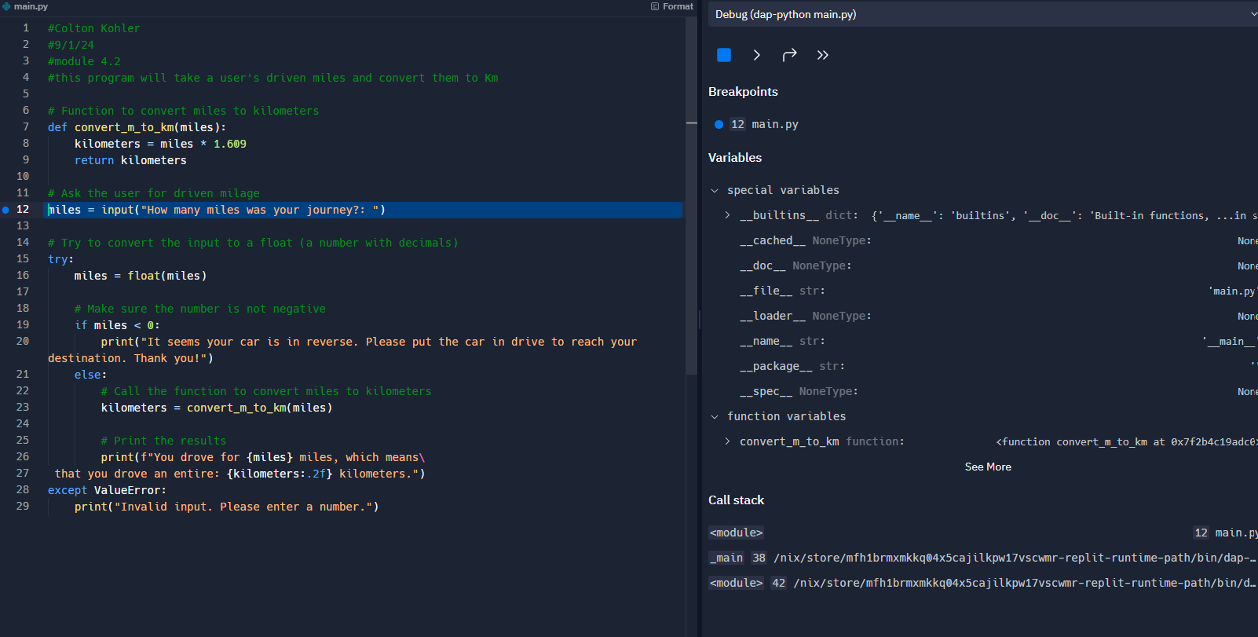

I’m not sure if I just picked a bad function, or if I’m not understanding where the breakpoints should go, but I can only get the debugger to show information at this point in the code.